**Assignment : Top Ten movies**

***Due Sunday, March 15, 2015 at 11:55pm.***

**Requirements:**

Your app must match an example as shown in figures 1 - 3 for your list of 10 movies in a browser. Make sure you check your work on any mobile emulator/simulator before submitting your work to Blackboard.

**Application Name:** Top Ten Movies

**Tasks:**

1. The opening screen displays the top 10 movies (see figure-1).
2. When the user selects one of the top 10 box office hits, the poster of that movie will be displayed. See figure-2.
3. When a user clicks the button “Go to IMDB page”, the Web site that corresponds to each movie on [www.imdb.com](http://www.imdb.com) opens. See figure-3.
4. When a user clicks the button “Return to List”, the screen will display the top 10 movies.

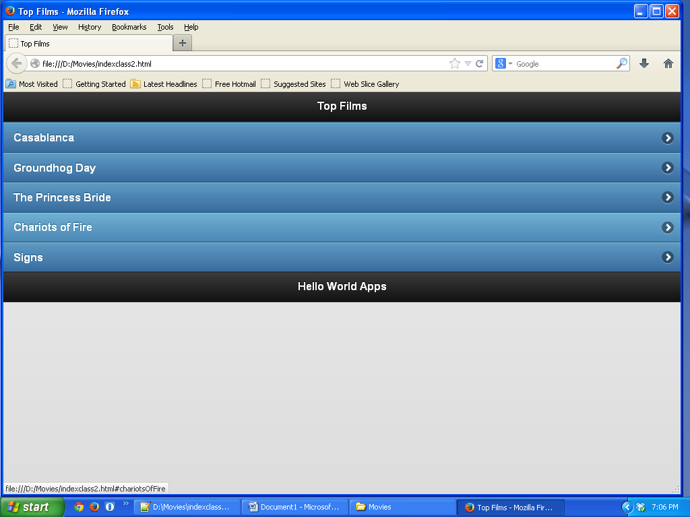

Figure-1

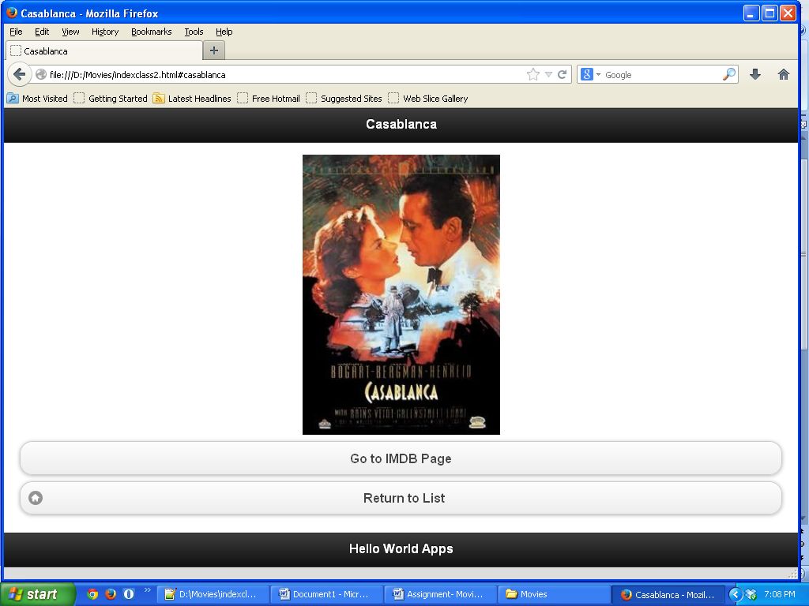

Figure-2

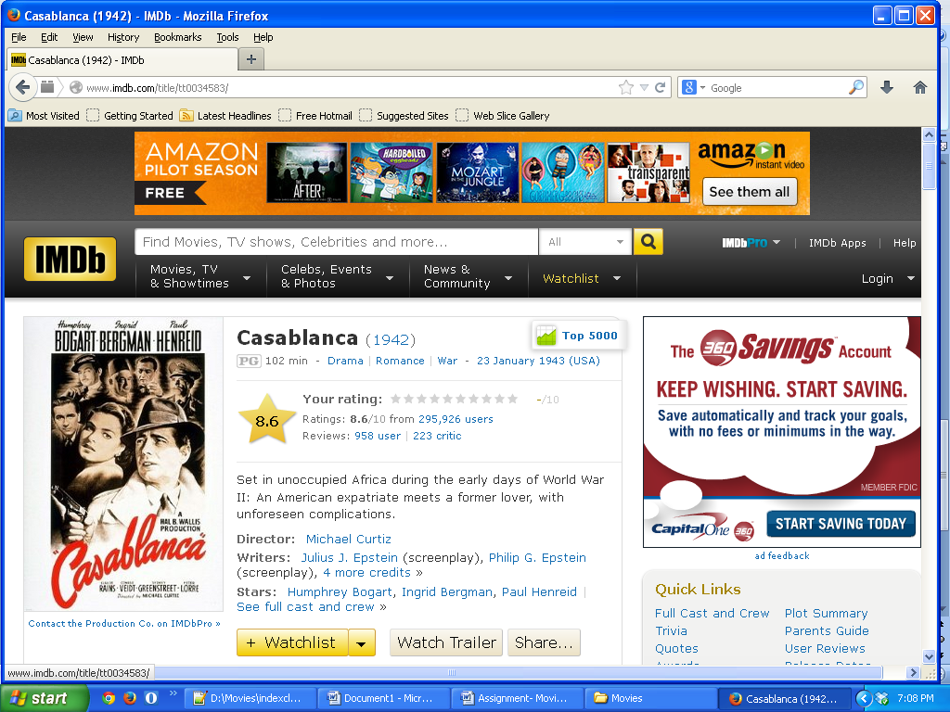

Figure-3